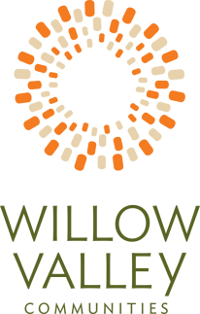
June 1, 2022 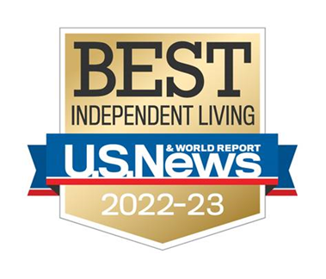
Contact: Maureen Leader | mleader@willowvalley.org | 717.464.6288
WillowValleyCommunities.org | LifeLivedForward.org
600 Willow Valley Square | Lancaster, PA 17602
FOR IMMEDIATE RELEASE
For Immediate Release

U.S. News & World Report Names Willow Valley Communities a
2022-23 Best Independent Living Community

Lancaster, PA – Willow Valley Communities, a premier 55-plus community in Lancaster, PA has been rated a Best Independent Living Community by U.S. News & World Report in its inaugural Best Senior Living ratings for 2022-2023.
U.S. News & World Report and its survey provider, Activated Insights, collected data on more than 3,000 communities throughout the continental U.S. and Hawaii, representing more than 80 senior living operators. Residents and families were also asked to rate their experiences on various aspects of senior living. From that data set, U.S. News analysts rated Willow Valley Communities as a “Best” in the category of Independent Living.
Willow Valley Communities’ chief marketing officer, Brian T. Rutter said he is delighted by the rating, but added that he is most humbled by the nearly 200 comments of praise that Willow Valley Communities residents and family members added to their survey responses. The comments are posted on the U.S. News & World Report’s web site.
Rutter further added how the “Best” Independent Living Community rating fits perfectly with Willow Valley Communities’ Life Lived Forward philosophy. “At Willow Valley Communities, we’re focused on rethinking retirement.
-MORE-
Willow Valley Communities Rated Best by U.S. News & World Report
Page 2 of 2
Our Residents embrace the idea of not looking back at the life that you had prior to retirement; rather, it’s about looking forward at the rich, thriving, passion-filled life that you’ve going to have ahead. Willow Valley Communities is a place where you can pursue your passions and live the lifestyle you choose. We embrace Life Lived Forward because we think about the possibilities that lie ahead in retirement.”
Contributing to Willow Valley Communities achieving the coveted Best in Independent Living rating are award-winning amenities that Residents enjoy as part of an exceptional lifestyle:
- 80,000 sq. ft. Cultural Center
- 30,000 sq. ft. Clubhouse
- 500-seat performing arts theater
- Aquatics and Fitness Centers
- Day Spa
- Outdoor tennis courts
- Bowling alleys
- Vintage arcade
- 12 Culinary Venues -- cafes to gourmet restaurants
- 100 clubs and groups
- World renowned programming and entertainment
####

Interview opportunities and professional photographs are available.
To schedule an interview or for more information, contact:
Maureen Leader, APR
Public Relations and Communications Manager
Willow Valley Communities
600 Willow Valley Square
Lancaster, PA 17602-4866
717-464-6288

About Willow Valley Communities
Willow Valley Communities is one of the nation’s leading retirement living developers and operators, and its campuses are home to more than 2,400 residents from 40 states. Located in Lancaster, PA – consistently ranked by U.S. News & World Report among the top five places to retire – Willow Valley Communities offers unparalleled 55+ residential experiences with beautifully designed homes, resort-quality amenities and services, and the assurance of Lifecare. Now in its almost 40th year of operation, Willow Valley Communities is one of only five communities of its type in the U.S. to score an “A” or better from Fitch Ratings. Visit http://www.WillowValleyCommunities.org

